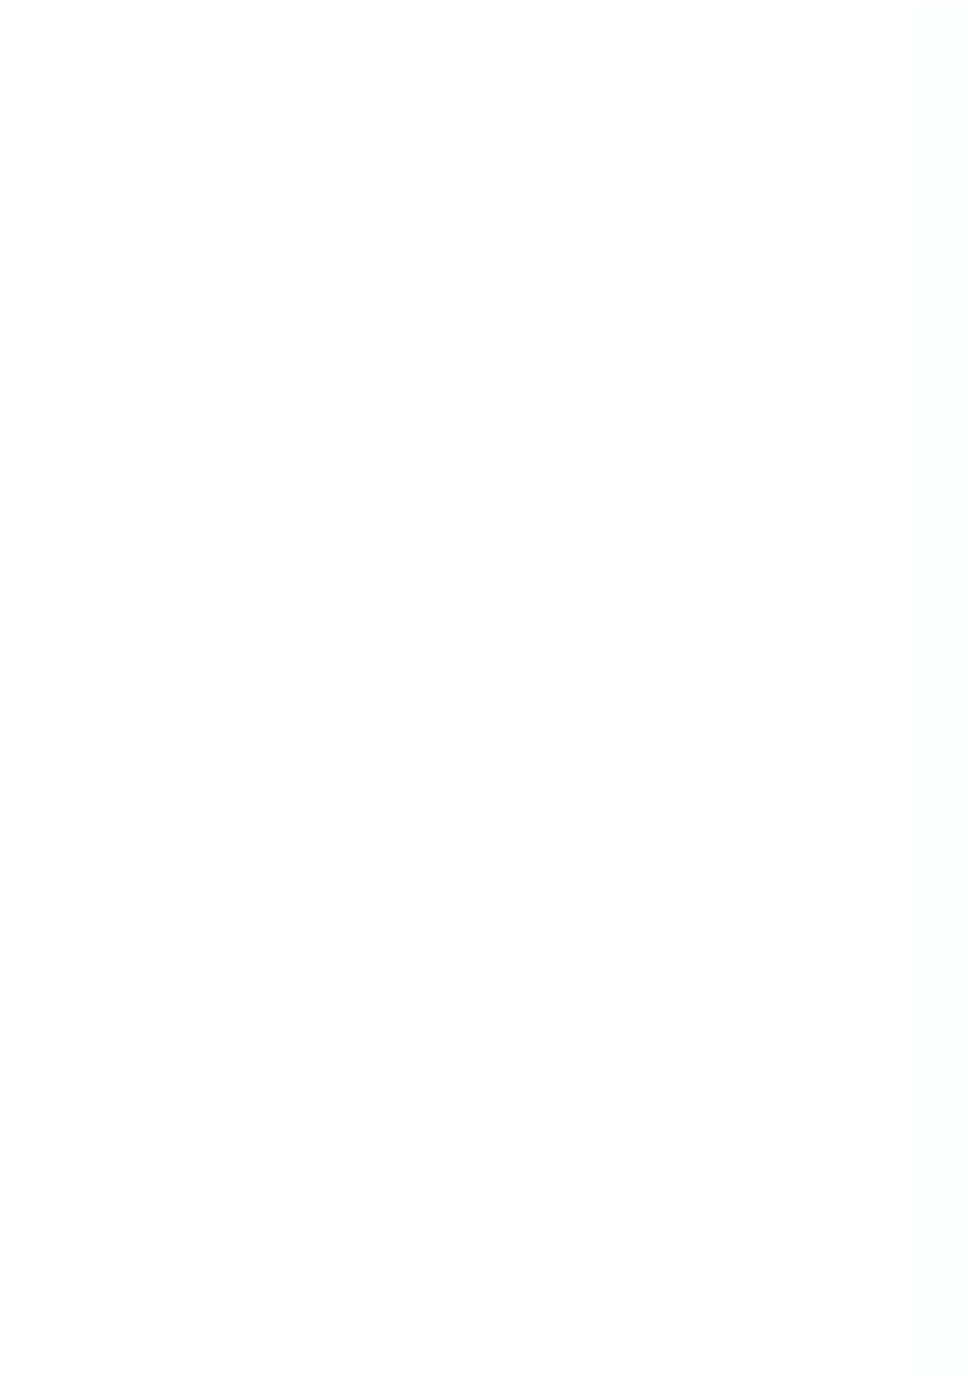

ABOUT ME

I take pride in maintaining a neat and organized workspace and enjoy working efficiently and accurately. I am eager to continue my studies and impart my knowledge to benefit the workplace. I am dedicated to sharing my experience with others and serving harmoniously and happily. My goal is to secure a challenging role in a reputable organization where I can expand my marketing skills knowledge and experience. I aim to fully utilize my training and expertise to make a significant contribution to the company's success.
GitHub - kaushal sudarshana

TECHNICAL SKILLS
- Computer Languages & Hardware: Proficient in Python, Java, JavaScript, C++, C#, HTML, CSS , Hardware Skills.
- Frameworks and Libraries: Angular, Node.js, React, Next.js, Express
- Creative Graphic Design (Adobe Creative Suite)
- Knowledge of AI tools Web Development, Front-end Development, Back-end Development
- Proficiency in Microsoft Office (Word, Excel,
PowerPoint)

SOFT SKILLS
- Problem Solving & Team Cooperation
- Knowledge related to Pharmacology, Drug Regulation
- Effective Communication, Knowledge Sharing, Project Management & Critical Thinking
- Time Management, Leadership, Adaptability,
Organizational Skills & Customer Service
- Marketing and skills
- Interpersonal Skills for Effective Client Marketing

LANGUAGES
- Sinhala - Native
- English - Intermediate

REFERENCE
- Indika Fernando
President's College Maharagama
Phone: +94706377092
- Ashani Koralage
Regulatory Pharmacist, Pharma Associates
Phone: +94719732669

Phone - +94720496500 Email - sudarshanakaushal12345@gmail.com Address - Kotikawaththe, Colombo, Sri Lanka LinkedIn - kaushal-sudarshana-773573203 SLASSCOM - public-profile/16874
BSE (UG), BSc (UG) & Nat Dip Sales Mgt
KAUSHAL SUDARSHANA
My Blog Page - Kaushal sudarshana

EXPERIENCE
- Web Developer Intern (Aus-eTech, Product Development) Jul - Aug 2025
Worked on building and maintaining web apps with Next.js, fixing bugs, improving performance, writing clean code, and managing daily GitHub commits.
- Accountant - Cashier (Laughs Supermarket Kolonnawa) 2021 (3 month)
I served the company with credibility and responsibility, seizing the opportunity to work collaboratively as a team.

PROJECT

- Capstone Project (OpenUOM) | Trainee Full-Stack Developer Program
Developed a school information management system using Angular, Node.js, and SQLite, showcasing modern web technology integration.
GitHub: GitHub repository.

- Codsoft Internship Program (Web Developer)
a calculator, a portfolio website, and a landing page. Detailed information and source code are available in the GitHub repository. The projects utilize the following technologies: Frontend: HTML, CSS Backend: JavaScript Additionally, I've showcased the outputs in a video posted on my LinkedIn account, where I've also shared the relevant certificate. For more information, please click the link.

- Codsoft Internship Program (Java Developer)
a Number Game, a Student Grade Calculator, an ATM Interface, a Quiz Application with a Timer, and a Student Course Registration System. Detailed information and source code are available in the GitHub repository. These projects utilize the following technology: Java. Additionally, I have showcased the outputs in a video posted on my LinkedIn account, where I have also shared the relevant certification. For more information, please click the link.

- Other
Here are additional web projects I've completed: a Photography web page, my personal CV, Sakale Fashions & Creations (using Canva), Sakale Fashions & Creations, and Nidhi Flora. Detailed information and source code are available in the GitHub repository.
These projects utilize the following technologies - Frontend: HTML, CSS, and JavaScript for more details, please visit the link.


- Bachelor of Software Engineering (Honors)
EDUCATION
2021 (Present)
The Open University of Sri Lanka
Expected Graduation Date :2026

- Bachelor of Science in Biological Science 2022 (Present)
Eastern University Sri Lanka
Expected Graduation Date :2026
- National Diploma in Sales Management
Sri Lanka Institute of Marketing (SLIM)

- Apprentice Pharmacist Sri Lanka
Medical Council
2021 (Present)
Expected Graduation Date :2026

- GCE Advanced Level (A/L) In Biological Science (2020)
Biology : C
Physics : C
Chemistry : C

- Open Learning Platform University of Moratuwa 2023-2023

CERTIFICATIONS

- Python for Beginners & Python Programming
- Web Design for Beginners, Front-End & Server-side web programming
- Professional Practice in Software Development
- Certificate in Software Development Atari City Campus 2018-2018
- SoloLearn Certificates: Successfully earned 8 certificates on SoloLearn.
View Testimonials
- Future Careers BRIDGE Programmed: Completed Fundamental Level and Customer Service courses offered by SLASSCOM. (Student ID No: 16874)
- Completion of a Mobile Application: Contributed to the successful completion of a mobile application project using Android Studio.

EXTRACURRICULAR
A C T I V I T I E S

- Senior Student Leader: Demonstrated leadership from 2015 to 2018.
- 2017 Debate Team Member
- School Leadership Roles:
  - President of School Science Club (2015-2017)
  - Secretary of the School Buddhist Association (2016-2017)
- Participation in Science Quiz Competition: Actively participated in Science Quiz Competitions at the Divisional (2015 - 2017)
- Achievements in Regional Sports Competitions: Attained excellence in regional-level sports competitions.

